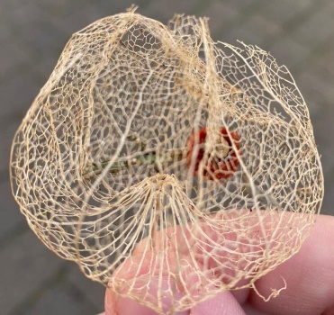 Newsletter 15.4.2020 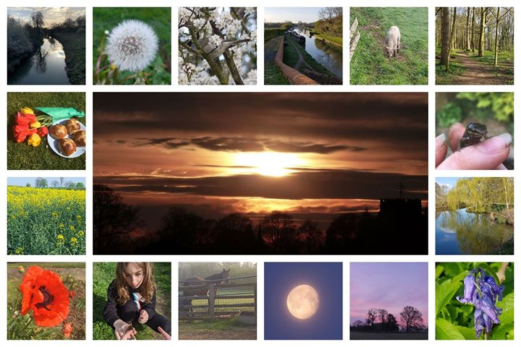
Renew Theme last week was ‘Take Notice’
Last week the 'Ways to Wellbeing' focus for Renew was 'Take Notice' Here are some images. Thank you one and all, including Melanie from TVBF who created the collage and Celia for the skeleton flower. This week the theme is Get Active...Please send me your images, thoughts etc for me to post as an encouragement.

Renew Online: From next week and during lockdown:
Monday via Zoom is a coffee and chill space. We will start at 2 pm at around 2.20 have a short prayer time - people can join in, mute and listen or go and make a cuppa at this point. The host will make sure we start on time and finish the prayer by 2:30. After this there will be an opportunity to continue chatting, people can bring something to do as they chat e.g. bring crochet or knitting.
Tuesday via Zoom we will follow the same pattern starting at 2 pm, prayer at 2.20 but at 2.30 do something else e.g. quiz, boggle, pictionary, online crosswords, hangman. I would be grateful for fresh ideas, support for hosting and ways that we can engage with those that are not on the internet. If you are someone who has hosted

Ways of keeping in touch - We are maintaining some contact via Whatsapp and are slowly looking at the action for happiness ideas. Last week it was reasons to be grateful. We held an Easter quiz on Tuesday 14th April 2020.
This week - Action for Happiness and one of the 5 Ways to Wellbeing is - Get Active even if you are stuck indoors. Please let me have any photos that we can use for the Renew Page or to encourage each other. The pictures can be serious or funny or if not any comments.
We have two more Zoom French lesson with Francesca Fleming coming up, there are still some places left if anyone would like to join. These are on the 23rd and 30th April at 12 noon. Please email me if you would like to join. Don’t forget Laura Patterson has a book club, currently reading, ‘The Choice’ and a writing activity ‘Dear Me@18’ why not join in! I have finished the book but haven’t started writing yet.
Contact me on wellbeingmanager169@gmail.com or 07761 041203

