Newsletter 8.4.2020
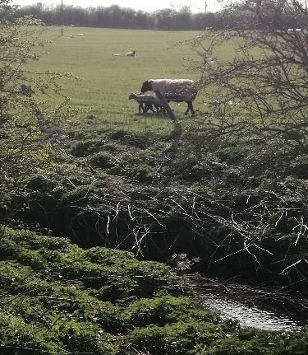 Renew Theme this week is ‘Take Notice’
Here is the first weekly newsletter. I will attempt to complete one each week and send it to volunteers and visitors. Please feel free to share this newsletter with anyone who may be interested.
We were deeply saddened to close our doors in March to visitors but renew169 is still operating all be it in a very different way!
This week I have been working on setting up ‘volunteer partners.’ The idea is that two volunteers keep in contact with each other on a weekly basis. It would be good to use one of the 5 ways to wellbeing to ask how people are doing. For example, this week the focus is on taking notice. Whilst out walking we noticed a wide variety of butterflies and were thrilled to see the new lambs in the field (hence the picture). Please let me know if you haven’t already if you are willing to be a part of this.
Ways of keeping in touch
We are maintaining some contact via Whatsapp and are slowly….looking at the action for happiness ideas. This week we looked at ten reasons to be grateful and came up with: Health, Friends, Family, Food, Exercise, Sunshine, Home, Memories, Music, Video calling and the Garden. Yes, I know that is eleven, but I have asked for ideas from more than one Whatsapp group! I have also asked some volunteers to keep contact with certain people from the Café who they have a connection with, and I am regularly messaging or phoning others. If you pray, then please keep in mind those that we are unable to contact.
Tomorrow we have a Zoom French lesson with Francesca Fleming, there are two places left if anyone would like to join.
There is a weekly coffee and catch up that anyone is welcome to join. Usually, this will be on a Monday but as it is Easter week it will be on Tuesday the 14th from 1.50 for prayer with others (who don’t want to be involved in prayer) from 2 pm.
I am researching activities that can be provided via Zoom, keep an eye out for a quiz afternoon and possibly origami, an art activity and some board games. All ideas are gratefully received and if anyone can lead an activity that would be amazing. Don’t forget Laura Patterson has a book club, currently reading, ‘The Choice’ and a writing activity ‘Dear Me@18’ why not join in! I am reading the book but haven’t started writing yet.
Next Week - Action for Happiness and One of the 5 Ways to Wellbeing - Get Active even if you are stuck indoors. Please let me have any photos that we can use for the Renew Page or to encourage each other. The pictures can be serious or funny or if not any comments.

