Renew169 Newsletter 13.5.2020 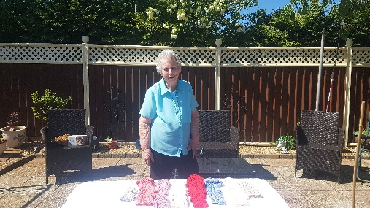
Renew4u169 Campaign - Here is a picture of Irene one of our visitors and keen supporter of renew169. She has pledged to knit 169 baby bonnets, to be donated to neonatal units in Milton Keynes and Northampton hospitals! Irene has inspired our challenge; can she inspire you too? Irene will be 90 in June, showing you are never too old to do things for others. Please keep an eye out for future information about our ‘renew4u169’ Pass it On Campaign
Please can I remind people to knit some flowers for our renew4u pass it on campaign. I will then purchase some ribbon to tie to the flowers and leave them with information for people to find.
Sad news – Sheila Burton’s (volunteer) sister Dot Archer sadly lost her battle with cancer and died on the 30th April. Dot was a visitor to Renew169. Please pray for all the family as they grieve.
Learning new things and being creative 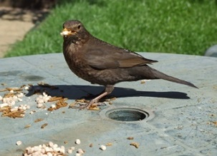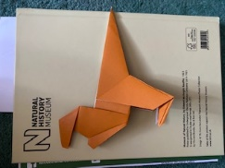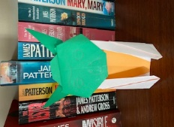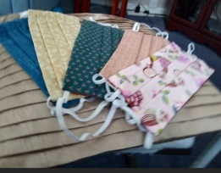
I set the challenge with our last newsletter for people to learn something new or demonstrate a way that they have been creative. As usual people have risen to the challenge! Anne Ellis has been feeding a mother blackbird and chicks who have nested in their pergola. The blackbird is now so used to Anne and her husband Graeme she comes to the table and eats while they stand and watch. A fortnight ago Anne and Graeme discovered a baby chick on the ground, just hatched and fallen out of a nest. Graeme introduced it into the blackbird nest and the mother bird has adopted it. Anne says she has had ‘technological adventures learning how to use airdrop to transfer them and that by the end of lockdown she will be a wizard!’ Reverend Paula Challen has said her new learning has been: ‘Online worship, how to juggle three sons at home whilst working’ but was afraid the time she thought she might have to be creative just hasn’t happened! Celia Stanworth has learnt some origami skills. Jacqui Hunt has read to her little grandson each day, via Zoom. They are currently reading The Hobbit. Jacqui describes this as ‘a pleasant activity which has come out of these strange and challenging times.’ Sheila Burton has been doing lots of baking and also learning the new skill of making face masks
For our next newsletter and as part of Meaningful May Action for Happiness; why not send a photo to a friend of a time you all enjoyed together? If you are both happy for it to be shared then please forward it to me for the next newsletter.
For any other information, to access support or to find out more about how you can volunteer please contact me on wellbeingmanager169@gmail.com or 07761 041203

